FOR DOCTOR, NURSE, RECEPTIONIST

HOMEPAGE

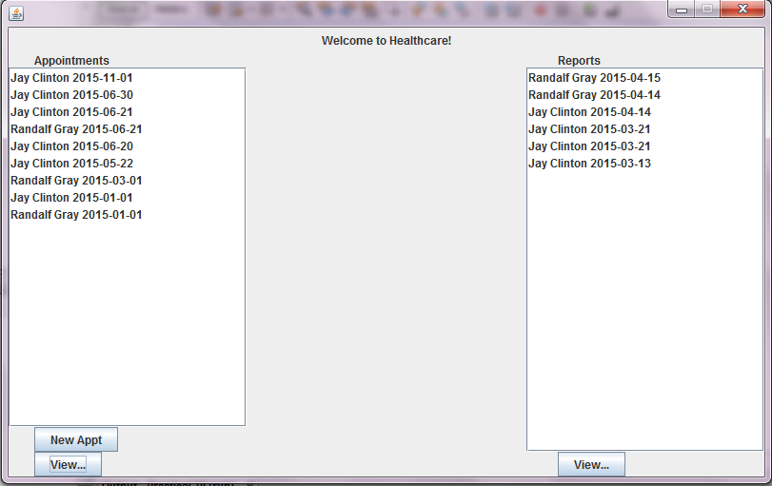

NEW APPOINTMENT

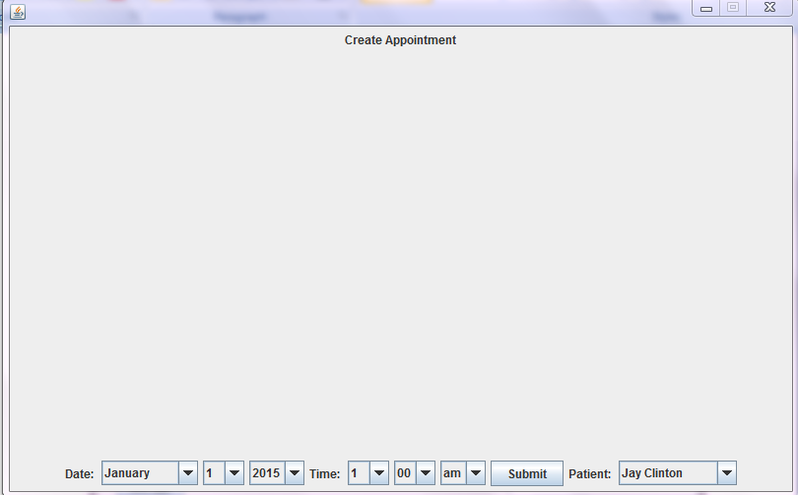

VIEW APPOINTMENT

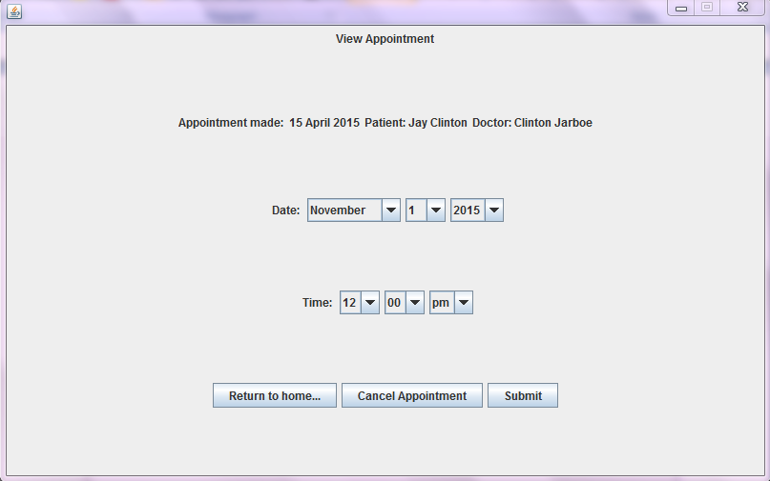

VIEW REPORT

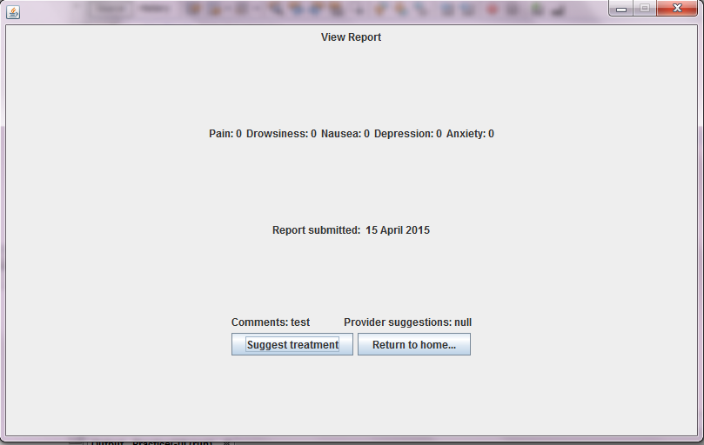

SUGGEST TREATMENT

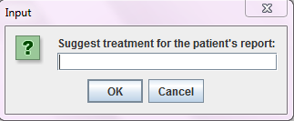

PATIENT LOGIN: HOMEPAGE

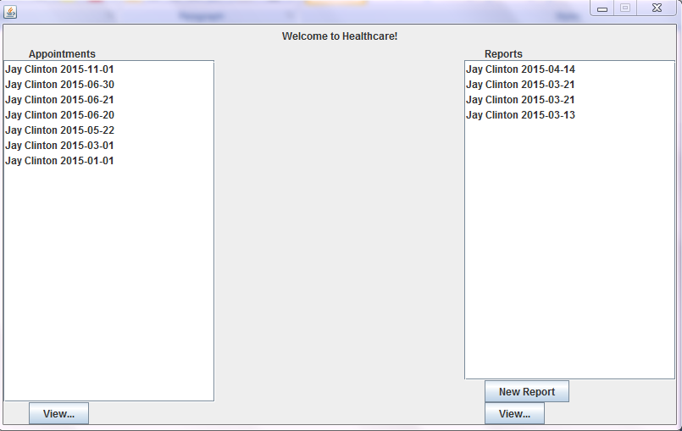

CREATE REPORT

VIEW APPOINTMENT

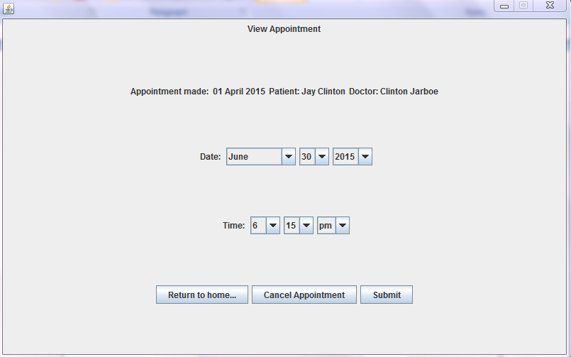

CANCEL APPOINTMENT

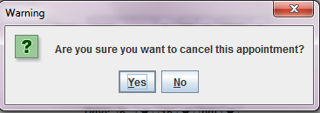

VIEW REPORT FOR PATIENT

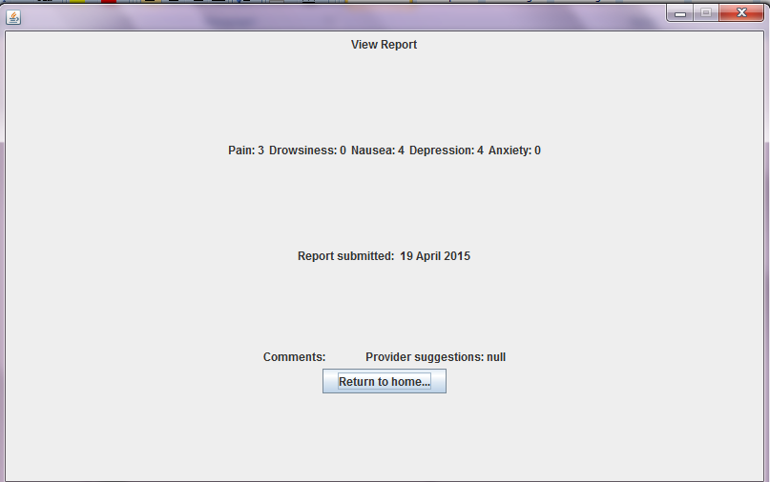

TOO MANY PASSWORD ATTEMPTS

